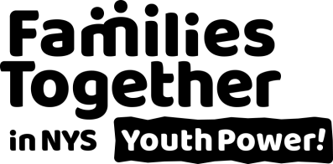
Membership Form
Amplifying youth voice and peer advocacy

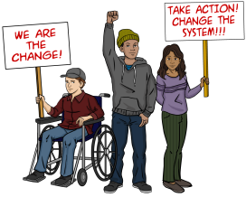
Mission: YOUTH POWER! is a statewide network of young people who have been labeled and are seeking change hosted by Families Together in NYS. Together we have decided to speak up about our experiences because no one knows what it is like for us better than we do. Through peer-to-peer mentoring, we empower young people to be active citizens, aware of government operations, their rights and the ability to use their voices to influence policy, practice, regulation and law. We are young people helping other people, ensuring availability of self-help, peer support and changing systems so that young people get the support they need with the respect and dignity they deserve.
As a member, you stand with hundreds of young people across the state in saying that you believe in what we are doing and want to strengthen the numbers behind our mission. Becoming a member means you get all the latest information about things that are important to young people and give as much of your time to us as you want or can. YP! of FTNYS is a safe space for those looking to organize advocacy, to speak out and amplify their voices for change. Stand proud as part of a movement working to change systems and pave the way for the next generation of youth by becoming a member today.

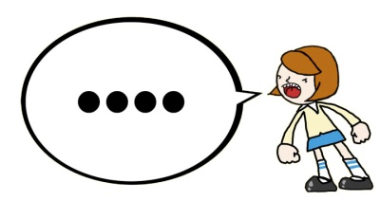
Benefits of Membership:
- You decide how involved you are but all members get the latest news, updates, and information on upcoming opportunities.
- Opportunity to participate in youth leadership and advocacy activities or become a YP! Ambassador.
- Networking and support for Youth Peer Advocates.
- Training, networking, and support to youth, youth groups, and organizations.
- Receive our newsletter and be a part of our events.
- Safe space to organize and amplify your voice for systems, services, and community change.
- Active members can build their skills, resume, and be more likely to receive scholarships to events!
Who can be a member?
- Young people ages 12-29 with a disability, emotional & behavioral challenges, or experience in New York State systems such as Special Education, Juvenile Justice, Foster Care, or Addiction Recovery. In short, if you are a young person who feels you have been labeled, then you can be a member.
- Young people who live in the State of New York.
- Members who turn 30 are able to remain involved in the network as a Peer Ally/Alumni.

To learn more, please contact us:
737 Madison Avenue, Albany, NY 12208 ypinfo@FTNYS.org 518-432-0333
www.FTNYS.org/YOUTHPOWER @YOUTHPOWERNY
Keep this page for yourself.

Membership Form
Amplifying youth voice and peer advocacy

For Staff Use
Entered: ____/____/____
Updated: ____/____/____
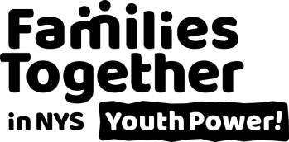

Please fill in as much of the form as you are able. We will use this information to add you to our mailing list, get to know your interests, and to inform you of events and activities in the YOUTH POWER! network. Please return your membership form to Families Together in NYS, ATTN: YOUTH POWER!, 737 Madison Avenue, Albany, NY 12208, Fax: 518-434-6478, Email: ypinfo@ftnys.org
The responses on this form will remain confidential. It helps us to know some important things about our membership demographics.

Name: _________________________________________ Today’s Date: ___/____/____

Date of Birth: ___/____/____ Pronoun: ☐He/Him ☐She/Her
☐Neutral (such as They/Them): ______________

E-Mail Address: ____________________________________________

Permanent Address: _________________________________________

City: ___________________ State: ___________ Zip Code: _________ County: ______________

Phone: ( ) ___________________ Other Phone: ( ) ___________________

Facebook URL: ________________________________________________

Do you want mail to go to another address (i.e. school, residential, office)? ☐Yes ☐No
If yes, please tell us:
Address Type: ☐ Office ☐ School ☐ Residential Facility ☐Other (specify): _________________

Alternate address: ___________________________________________ City: __________________

State: ______________ Zip code: _________ End Date (return to permanent address): ___/___/___

What is the best way to contact you?
☐E-Mail ☐Facebook ☐Telephone ☐Text ☐Regular Mail
Best times to contact: ☐Morning ☐Afternoon ☐Evening

Would you want materials in the future to be in Alternative formats?
☐Large Print ☐Text Only ☐Electronic Version ☐Braille ☐None apply

Are you a member of a local youth group? ☐Yes ☐No
If yes, which one? ______________________________________________
What type of activities are you interested in? (check all that apply)
☐Peer Advocacy ☐Systems Advocacy

What activities are you interested in? (check all that apply). Please be aware, because our network is statewide, most activities take place by phone and web meeting.
☐ Outreach in Action Working Group (newsletter, publications, videos, campaigns, lead with activism and advocacy)
☐ Special Events (helps plan major events, such as the Families Together in NYS annual conference youth track and University of YOUTH POWER!)
☐ YP! Ambassador (be a voice of the region, help plan events & spread the word!)
☐ Peer Leader Support and Development (professional development, networking, and support for
Youth Peer Advocates)

What best describes your gender identity? ☐Male ☐Female ☐______________
Which race/ethnic group do you identify with the MOST? (Check one)
☐African American ☐Asian/Pacific Islander ☐European/Caucasian ☐Hispanic/Latin
☐Native American ☐Other (specify): ________________

Do you identify as a part of the LGBTQIA+ community? ☐Yes ☐No ☐No, but I’m an Ally
Do you identify as transgender? ☐Yes ☐No

Do you have a disability? If so, check all that apply.
☐Developmental/Intellectual ☐Emotional/Behavioral ☐Health ☐Hearing ☐Learning
☐Mobility ☐Visual ☐Other (specify): _____________

What systems have you personally been involved in? (Check all that apply)
☐ Addiction Recovery: Alcoholics Anonymous/Narcotics Anonymous (AA/NA), Home and
Community Based Services (HCBS), Inpatient/Outpatient Services, etc.
☐ Child Welfare: Foster Care, Child Protective Services, etc.
☐ Criminal Justice: Detention Centers, Person In Need of Supervision (PINS), Probation, etc.
☐ Developmental/Intellectual Disability Services: Occupational/Physical Therapy (OT/PT), Social
Skills Training, Supported Education/Employment, etc.
☐ Employment Services: Career Centers, Vocational Rehabilitation Services, etc.
☐ Mental Health: Psychiatric Services, Single Point of Access (SPOA), Therapy Services, etc.
☐ Special Education: Have an Individualized Education Plan (IEP), 504 Plan, etc.
☐ Temporary and Disability Assistance: Supplemental Nutrition Assistance Program (SNAP),
Supplemental Security Income/Social Security Disability Insurance (SSI/SSDI), Temporary
Assistance, etc.
☐ Other (specify): ___________________________________________________________

Have you been in a residential placement such as a residential treatment facility, community residence, foster boarding home, kinship foster home, or rehabilitation center? ☐ Yes ☐ No

Would you be willing to participate in speaking opportunities like speak outs, panels and workshop’s and can we contact you about them? ☐Yes ☐No

