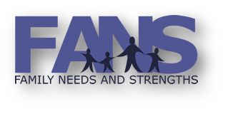

FPA’s Yearly Recertification

Do you have questions, are you struggling, or do you want support with the test?
Please Join Our FANS Technical Assistance
Office Hours - Zoom Call
10:00 AM to 11:30 AM
September 16th pre-registration is required by September 14th
October 21st pre-registration is required by October 19th
October 28th pre-registration is required by October 26th
November 4th pre-registration is required by November 2nd

Send email to
Laurie Rivera at Lrivera@ftnys.org
Questions: Call Nancy Craig 716-432-6238

